Superhydride BaSiH8 stable at ambient pressure and temperature

*Experimental team:*

Dmitrii Semenok, Di Zhou, Dominique Laniel, Umbertoluca Ranieri, Sven Luther, Hannes Kuhne, Yuki Nakamoto, Katsuya Shimizu, Kirill Pervakov, Andrei Sadakov, Vladimir Pudalov, and Ivan Troyan

**Abstract**

**Results**

*Synthesis of precursor (BaSi)*

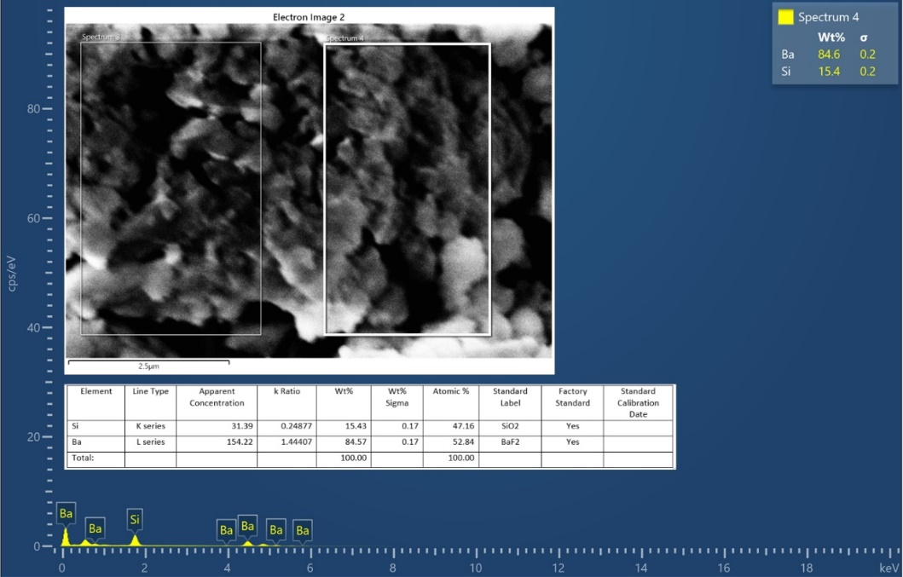

Starting BaSi was synthesized by cold mechanochemical synthesis: grinding for 1 hour an equimolar mixture of Ba and Si in a ball mill under argon atmosphere. According to the EDX and XRD analysis, there are regions with different Ba:Si ratios, including phases BaSi, Ba2Si and BaSi2.



PXRD analysis of the parent compound confirms the presence of *Cmcm*-BaSi. The diffraction pattern of the parent compound is very complex, indicating the presence of other barium silicides (BaSi2, Ba3Si4) as well as probably the oxidation product Ba2SiO4 detected by single-crystal diffraction methods (TAIWAN beamline, SPring-8).

*Optical photographs*

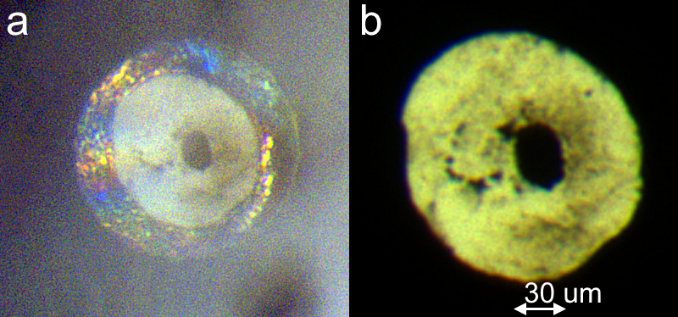  
BaSi/AB sample before laser heating at 31-32 GPa. After laser heating the pressure did not change GPa (DAC BS1)

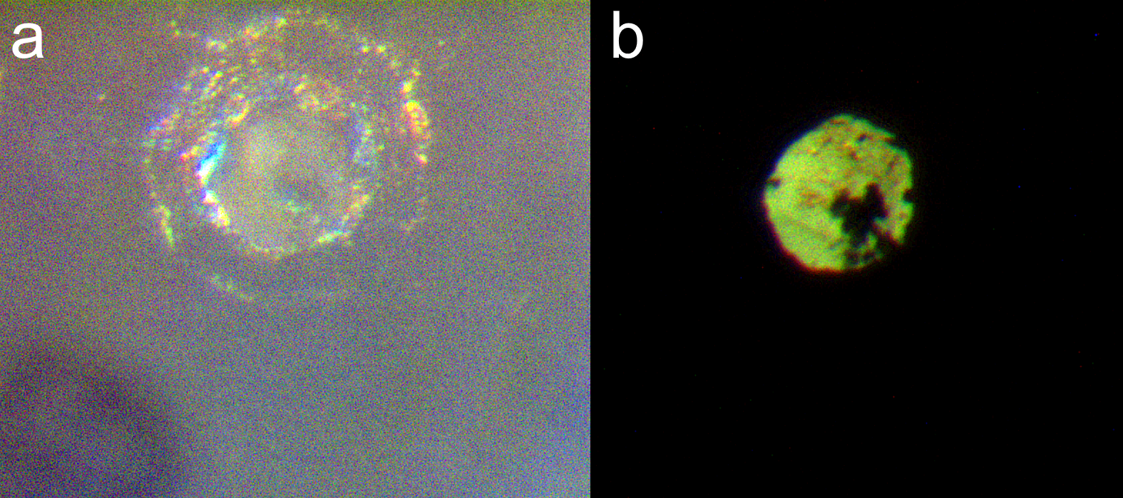

BaSi/AB sample before laser heating at about 50 GPa. After laser heating the pressure dropped to 38 GPa (DAC BS2)

*High-pressure synthesis of BaSiH8*

After laser heating of the BaSi with the excess of AB at 31 GPa (DAC BS1), the formation of the target cubic BaSiH8 is observed, the diffraction pattern of which persists when the diamond chamber is decompressed until it is fully opened. PXRD measurements were performed at SSRF and SPring-8, with an X-ray beam sizes about 10×10 microns and above. Thus, formation of the product was observed in a significant volume of the high-pressure chamber.

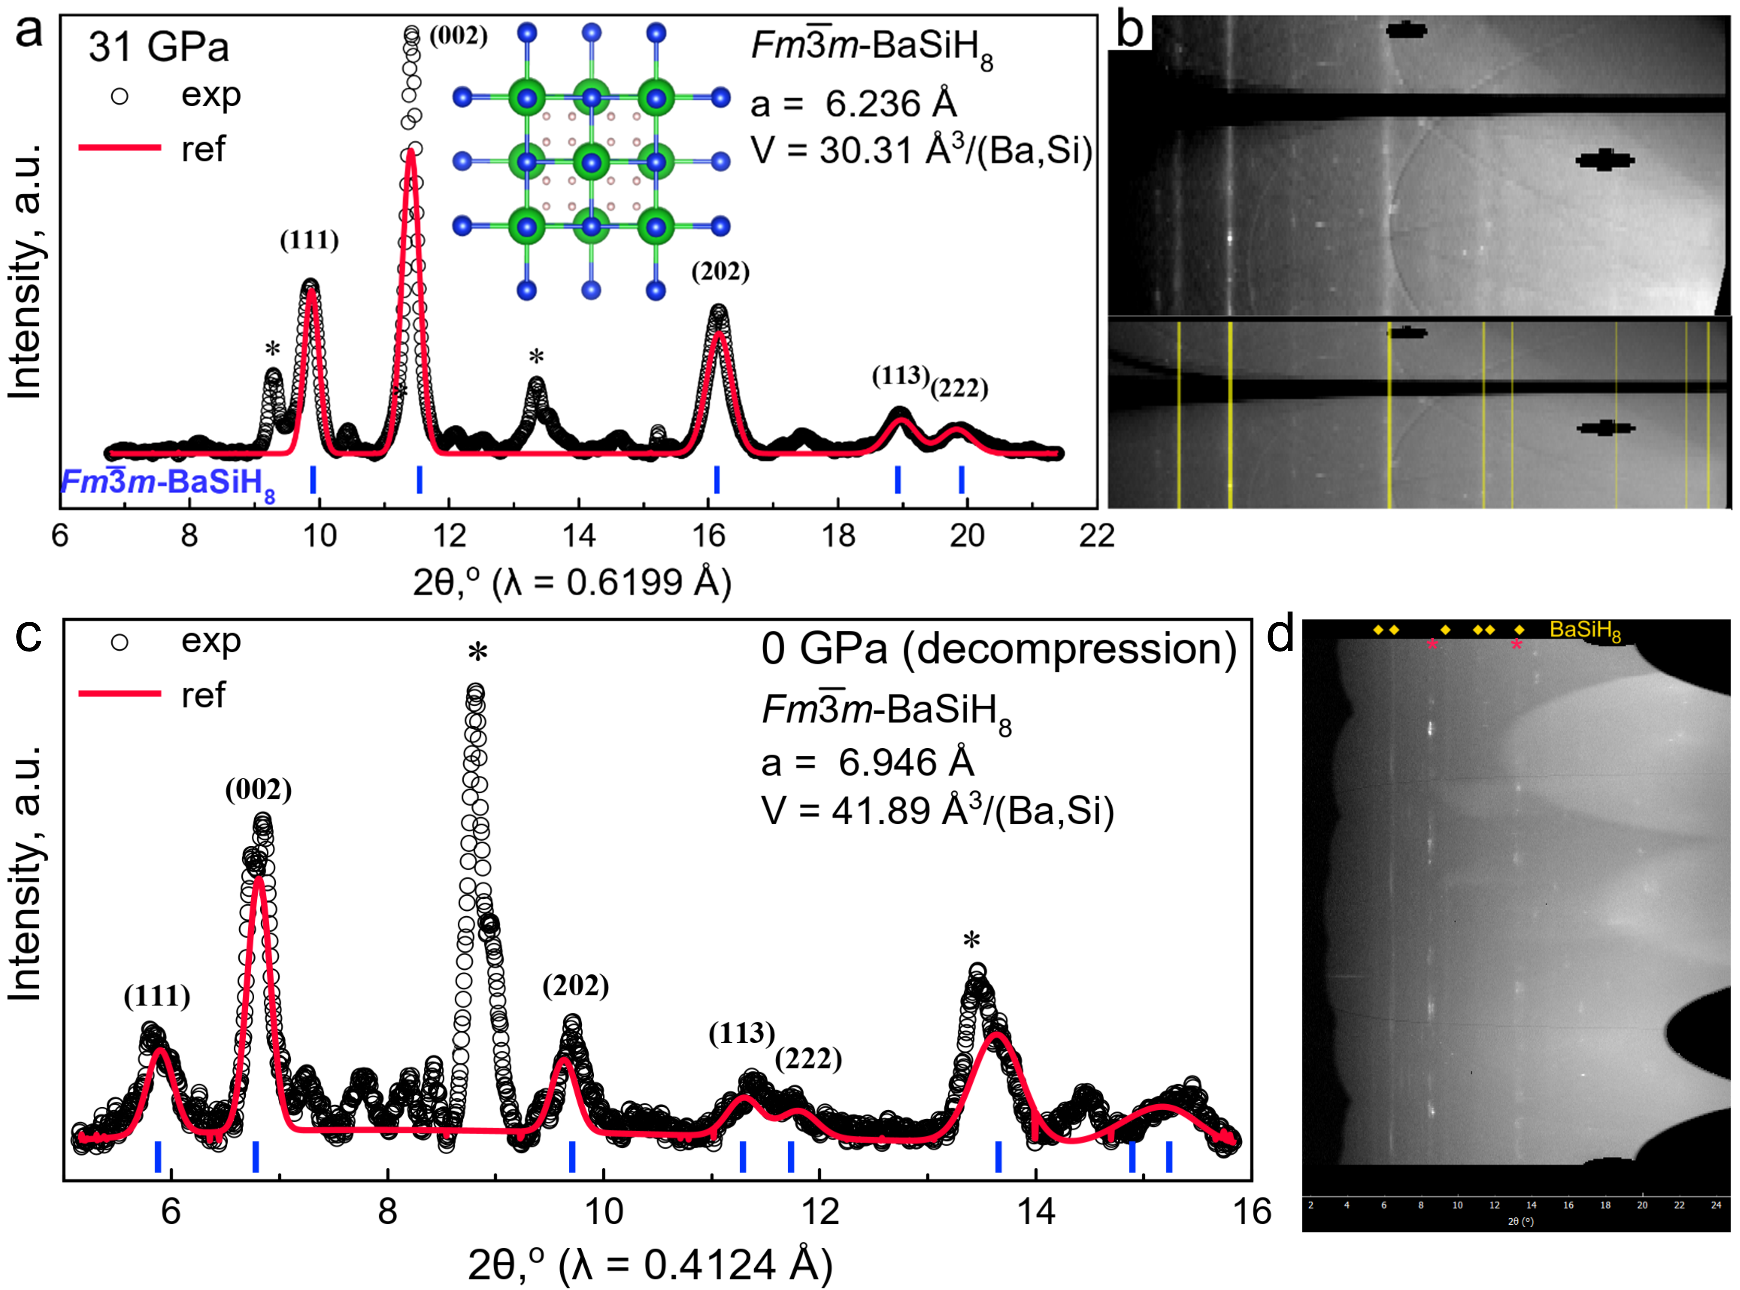

The intensity distribution remains constant after opening of the DAC, indicating that the ordered true ternary sublattice of heavy atoms *Fm*-3*m* (Ba, Si) is preserved even at atmospheric pressure. Namely, the reflection of (111) is significantly weaker than that of (002) and is close in intensity to the reflection of (202) at both 31 GPa and 0 GPa. Because of the low intensity of the diffraction pattern, we cannot exclude the presence of some distortion of the cubic lattice.

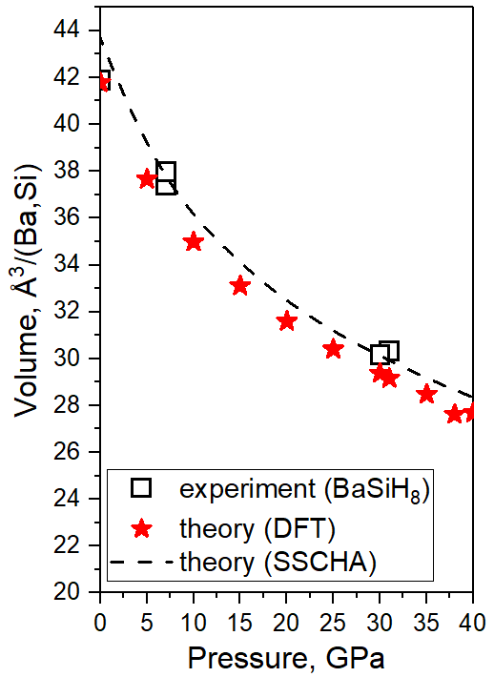

An important argument in favour of BaSiH8 formation is the very good agreement between the experimental and calculated unit cell volume (see Table 1).

**Table 1.** Unit cell parameter and volume of cubic BaSiH8. Results from SPring-8 and SSRF.

|  |  |  |  |
| --- | --- | --- | --- |
| **Pressure, GPa** | **a, Å** | **V, Å3** | **V­BaSi, Å3/(Ba,Si)** |
| 31 | 6.236 | 242.50 | 30.31* |
| 30 | 6.226 | 241.35 | 30.17 |
| 7 | 6.386 | 260.44 | 32.55 |
| 0 | 6.906 | 335.13 | 41.89 |
| DFT: 31 GPa | 6.156 | 233.30 | 29.16 |
| DFT: 38 GPa | 6.045 | 220.94 | 27.62 |

*SSRF experiment

Before loading, and in a high-pressure DAC, as well as before and after laser heating, the sample is an opaque material, presumably a metal or narrow bandgap semiconductor.

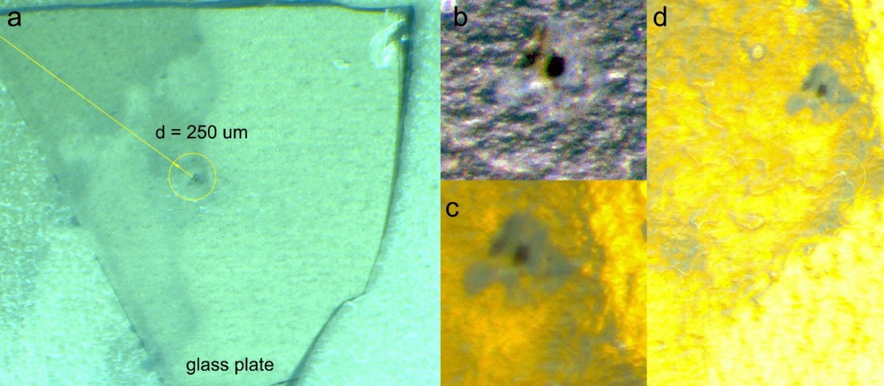

Optical photographs of the BaSiH8 sample after opening the DAC and transferring it to a glass plate at different magnifications. The sample (dark spot in the center) shows no visible signs of decomposition, remains opaque, but possibly reacts with an organic adhesive used to glue the sample to the glass.

*Raman spectroscopy*

A systematic study of Raman scattering of BaSiH­x samples is beyond the scope of this work. Raman spectra of the samples were recorded using 532 nm excitation laser of the Renishaw Raman inVia system with 60-120 s exposition time at 1-2 mW of power, and focusing lens with x20 magnification.

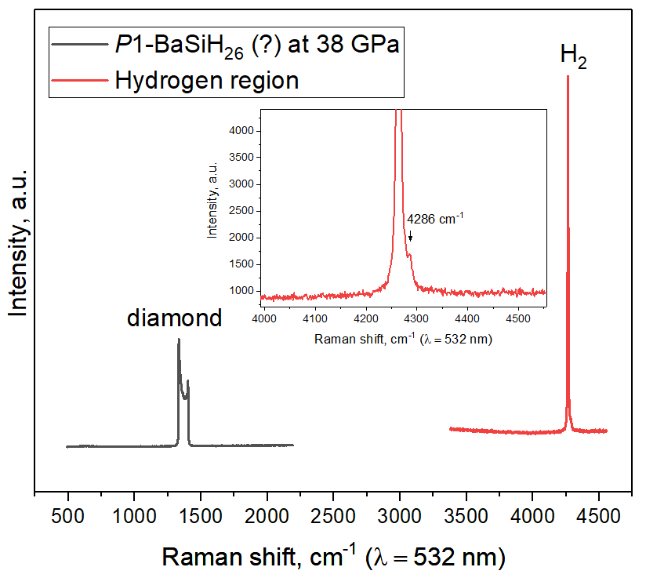

Raman spectrum of the sample at 38 GPa (diamond scale). There is a large peak from molecular hydrogen, which, however, corresponds to a much lower pressure (24 GPa, H2-scale). It is possible that this peak corresponds to molecular hydrogen within the BaSiHx structure. There is also a small shoulder at the hydrogen peak at 4286 cm-1. Raman spectra are available on the github: <https://github.com/mark6871/BaSiHx-project/tree/Raman>



Since BaSi, and BaSiH8 are (bad) metals by nature, their Raman signal is rather weak and cannot be confidently separated from various Ba silicides, Ba-Si oxides and semiconducting hydrides. After laser heating, the formation of excess hydrogen is observed with clearly detectable H2 vibrons and rotons at medium (32-34 GPa) and low (1.6 GPa) pressures. Whereas before heating at 60 GPa there are signals in the region of N-H vibrations, possibly related to NH3BH3. Before laser heating, in one case we observed a double signal around 4394-4431 cm-1. After laser heating this signal is no longer observed, but there is a new signal at 3213 cm-1. There is also an additional peak of H2 at 4275 cm-1 at 1.6 GPa (possibly from molecular BaSiHx polyhydrides or molecular H-sublattice of BaSiH8).

  
Raman spectrum of the BaSi/AB sample after laser heating at 38 GPa (diamond pressure scale, Akahama). The region of interest is outside the laser heating point. There are peaks at 4492 cm-1 and around 2062 cm-1.

*Possible formation of higher BaSi polyhydrides*

As it was found for many alkali (Rb, Cs) and alkaline-earth metals (Ba, Sr), their reactions with hydrogen at high pressure can proceed with formation of higher molecular hydrides with H-content > 92-95 at%. We cannot exclude such a scenario for the Ba-Si-H system as well. In particular, in the experiment at 38 GPa (DAC BS2) we did not detect the formation of BaSiH8, but instead some other compound was formed, the X-ray diffraction spectrum of which is similar to *P*1-BaSiH26 found by DFT calculations.



*Transport measurements*

Transport studies were performed in several cells (DAC **BS3** in LPI, **BS4** in LPI, **BS5** in HPSTAR ) using a four-contact van der Pauw scheme.



Despite the prediction of outstanding superconducting properties of BaSiH8 (*T*С > 70-80 K in the range of 50-100 GPa), in the experiment we detect a superconducting transition only at rather low temperature of about 9 K at 142 GPa (DAC BS3). Probably several superconducting phases are present in the BaSiHx sample, which explains the multistage character of the electrical resistance drop. It is interesting to note that the detected superconductivity turns out to be very stable to the external magnetic field, the critical value of which is *B*C2(0) ≈ 13-16 T.

Remarkable difference between the predicted and observed *T*C values can be explained by isomerisation of polyhydrides resulting in stabilisation of the molecular sublattice instead of the atomic hydrogen sublattice. This also explains the extremely high stability of such a polyhydride with respect to decompression at room temperature.



At low pressure (30 GPa, DAC BS4), transport measurements of BaSiHx hydrides indicate their semiconducting character, negative *dR/dT*, although the detected bandgap is extremely small (< 1 meV). No signs of superconducting transition are observed. Resistance of the sample is about 136 Ω at 300 K, conductivity is 158 S/m, or 0.0063 Ω×m. Metallization of barium-silicon hydrides is expected at pressures around 50 GPa.

HPSTAR: pseudo van der Pauw scheme (3 electrodes, 1 was broken, DAC BS5) also shows no trace of a superconducting transition at temperatures above 78 K (see Supporting Information).

*1H NMR measurements*

1H NMR experiments with BaSiHx diamond anvil cell (DAC BS6) at ~30 GPa and 100-150 K. The main conclusion is that there is a pronounced broad hydrogen signal, typical of solid-state NMR, with spin-lattice relaxation time T1 significantly lower than in the NH3BH3, but significantly higher than it should be for the metallic hydrogen sublattice.

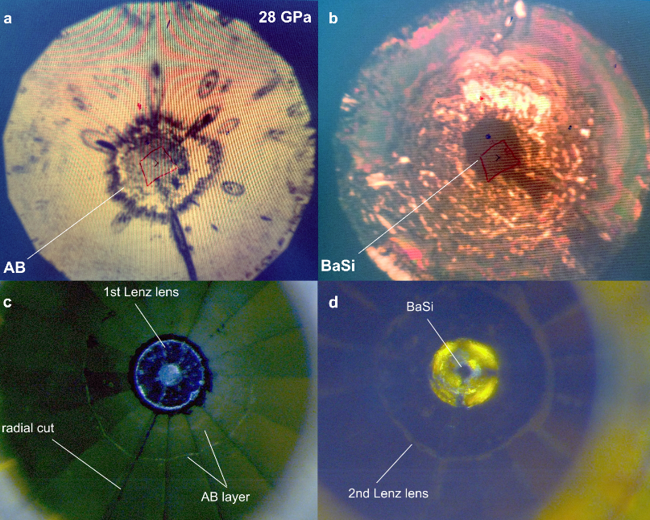

**Figure 0.** Photographs of a diamond chamber culette with a BaSi/AB sample under a pressure of 28 GPa with different magnifications and lighting, from piston and cylinder. The sample is opaque to visible light. The Lenz lens is made of copper. Gasket material is tungsten. Insulating layer is Ta2O5.

DAC with a BaSi/AB sample at 28 GPa, equipped with two Lenz lenses [T. Meier et al. *Matter Radiat. Extremes* 6, 068402 (2021)] (Figure 0) and two trimmer capacitors (10 nF), was heated using a pulsed infrared laser (Nd:YAG, 1 μm). After the chemical reaction, the BaSiHx sample was examined using nuclear magnetic resonance spectroscopy in a magnetic field of 7.25 T (the resonance frequency of 1H nuclei was 308.8 MHz) at two temperature points: 150 and 100 K. Failure of the DACs electrical circuit at low temperature and loss of resonance prevented the NMR study below 100 K. The spin-echo detection mode was used, in which a 90o pulse had a duration of 2 μs, RF power is 28 % out of 250 W, and delay time (D1) was about 100 ms. Nutation 2D scan of pulse duration from 1 μs to 8 μs with a step of 0.5 μs, and pulse power from 10 to 30 % with a step of 5 % indicates that 90o spin-echo conditions are achieved at 6.5 μs pulse duration and 25 % of power. However, considering the total time required for experiment, we mostly used shorter pulses of 2 μs with higher power of 28 %. A detailed description of the experiment can be found in the Supporting Information.

As a result, 1H NMR spectra of BaSiHx were obtained (Figure 1). As can be seen, the main signal from the sample with a width of 44–60 kHz (142–194 ppm) corresponds to a shift of –39-43 ppm and can consist of two components, where the smaller peak corresponds to the shift about + 50 ppm. Moreover, a D1-scan at 150 K in the range of D1 from 100 to 2000 ms indicates the presence of another peak at around – 400 ppm (Figure 1c) with a significantly longer spin-lattice relaxation time than the main reaction product.

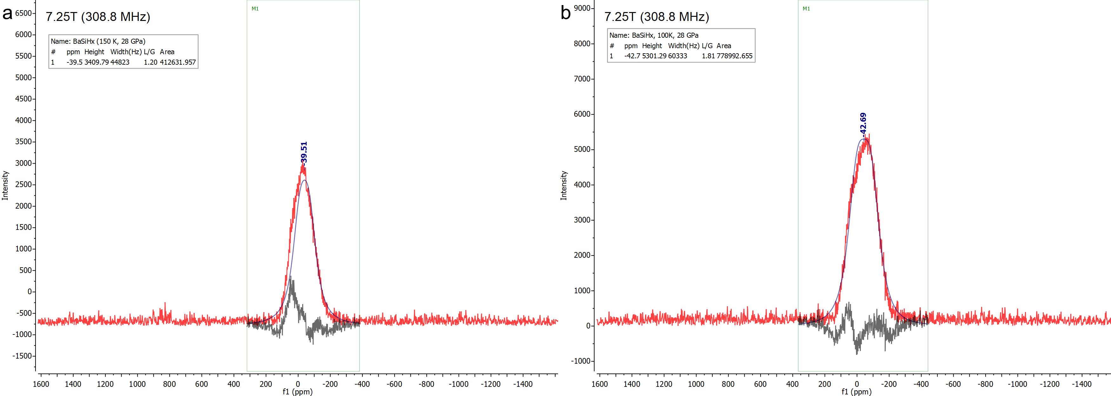

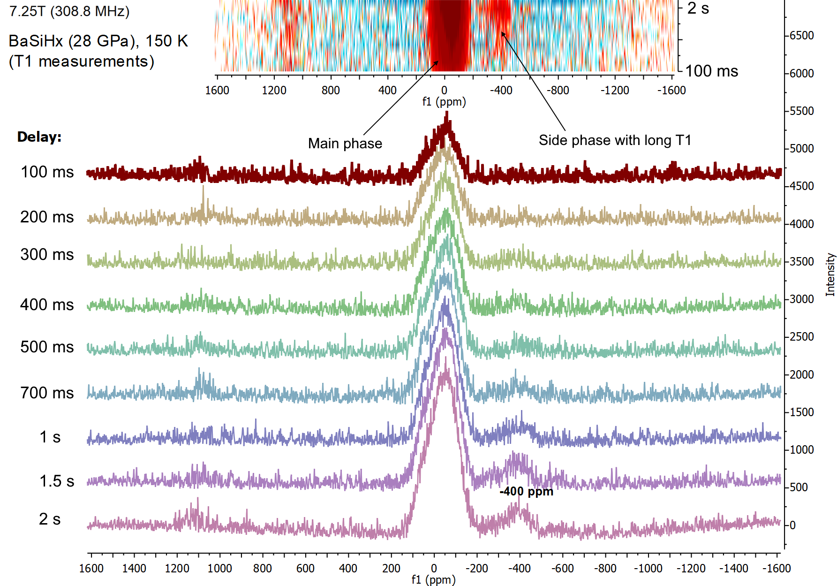

**Figure 1.** 1H NMR (308.8 MHz, 7.25 T) study of BaSiHx at 28 GPa at: a) 150 K, b) 100 K. (c) D1-scan in the range of delay time from 100 to 1900 ms at 150 K.

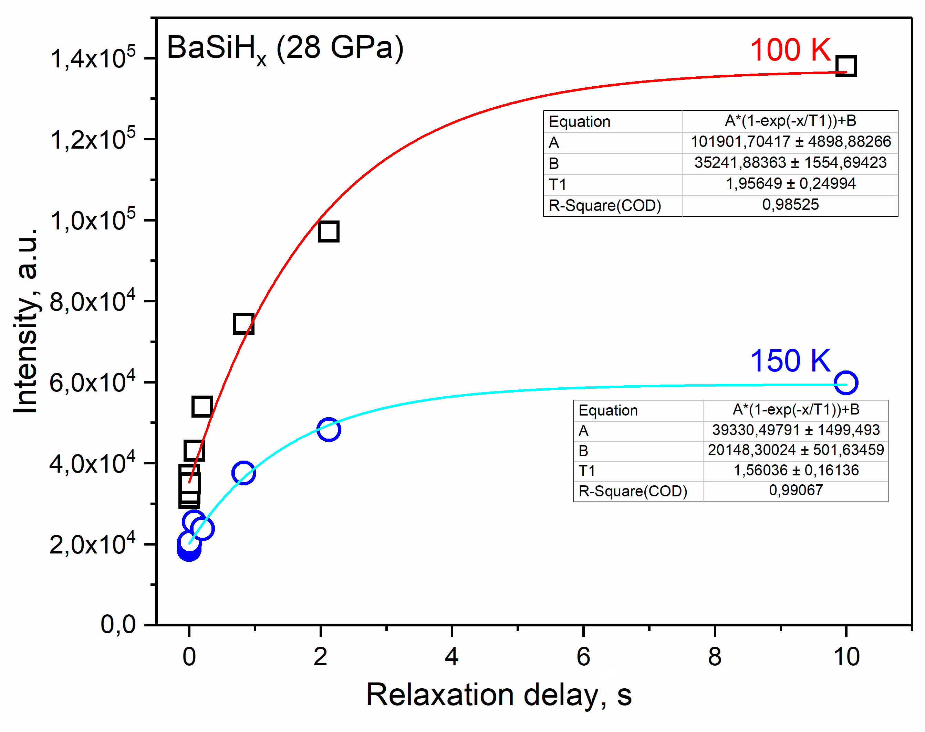

**Figure 2.** Interpolation of the intensity of the main 1H NMR signal from the sample depending on the signal detection time (τ1) carried out using an exponential decay function at 100 and 150 K.

Thus, the sample contains several phases, which is confirmed by the complex nature of the X-ray diffraction spectra. Estimations of the spin-lattice relaxation time T1 for the main phase (Figures S1, S2) show that the T1 increases from 1.5 to 2 seconds when the sample is cooled from 150 to 100 K (Figure 2). It should be noted that since full saturation of the signal was not reached even at D1 = 10 s, we cannot be completely sure of the T1 values. Such long relaxation times also serve as an additional argument in favour of the semiconducting character of the obtained barium-silicon hydrides.

*Figures for Supporting Information*



**Figure S1.** Inversion recovery experiment in order to determine the spin-lattice relaxation time T­1 in BaSiHx at 28 GPa and 150 K. Delays (τ1) from 1 μs to 10 s were used.



**Figure S2.** Inversion recovery experiment in order to determine the spin-lattice relaxation time T­1 in BaSiHx at 28 GPa and 100 K. Delays (τ1) from 1 μs to 10 s were used.

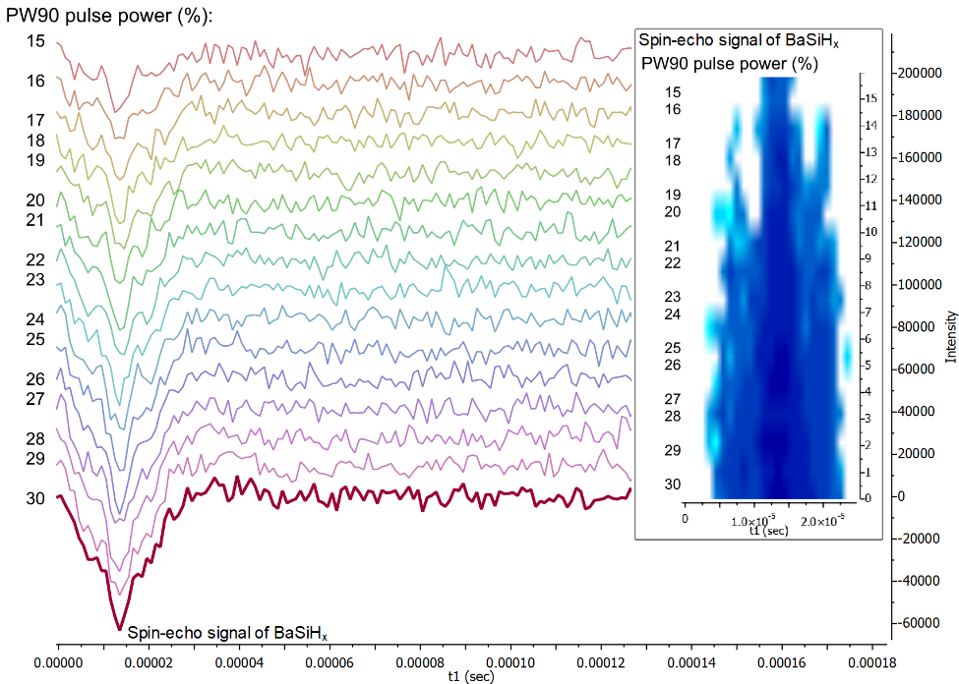

**Figure S3.** Spin-echo nutation experiment with different 90o pulse power (pw90) from 15 to 30 % (where 100 % is 250 W) at the constant RF pulse duration (2 μs). Sample is BaSiHx at 28 GPa and 150 K. Inset: colormap of intensity of the spin-echo signal.

**Conclusions**

Ba, Sr, Cs, and Rb polyhydrides are promising from the point of view of stability under ambient conditions. Their compounds can be "pumped" with hydrogen at high pressure of several hundred thousand atmospheres, and then remain stable for a long time after the load is removed.

**References**